CS 255 System Design Document Template

UML Diagrams

UML Use Case Diagram

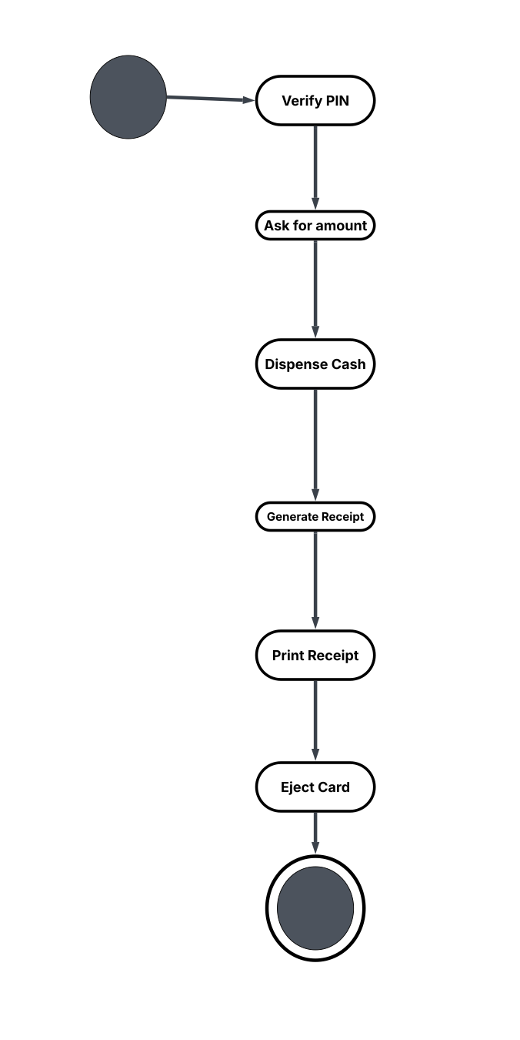

UML Activity Diagrams

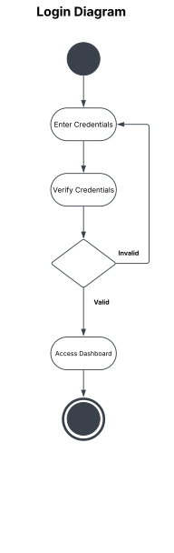

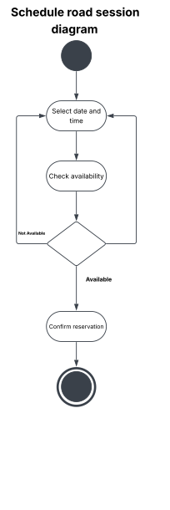

UML Sequence Diagram

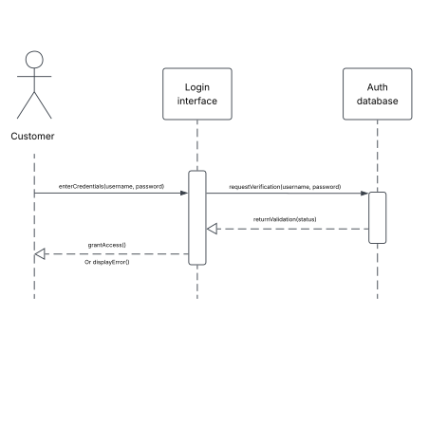

UML Class Diagram
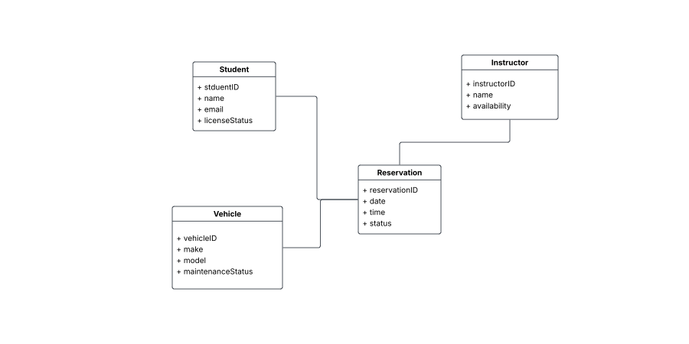

Technical Requirements
To implement the DriverPass system, a cloud-based infrastructure (like AWS) is required to host the platform which allows the opportunity for scalable performance during high traffic booking periods. Software requires a relational database management system (like MySQL, PostgreSQL) to store and link data such as student profiles, instructor availability, and vehicle maintenance logs. Users will access the platform through either a web or mobile app. To connect those front-ends to the database securely, we'll need to build a REST API. The infrastructure must be secure, enforcing strict security protocols. We'll encrypt all data traffic using SSL/TLS and use secure hashing to protect customer logins.

